STOCK MARKET PREDICTION USING MULTI-SOURCE MULTIPLE INSTANCE LEARNING
Methodology, Novelty and Key Contributions
Department of Computer Science and Engineering, [COLLEGE NAME]
Batch C4 (CSE-C) · Academic year [ACADEMIC YEAR]
Table 1: Project team
S.No. | Student name | Roll number
1 | Pottepaka Lingaswamy | 23K91A05J7
2 | Maduna Naveen Kumar | 23K91A05D7
3 | Meedigeri Keerthi | 24K95A0517
4 | Mareddy Sai Karthik | 23K91A05E8

Project guide: K Anusha
Chapter and section numbers quoted in the text (for example Chapter 8 or Section 6.2) refer to the full project report, 17.Final Document. Figures and tables in this document are numbered from 1.

1. METHODOLOGY
This document describes how QuantPulse works from end to end and what is new in it. Part 1 gives the pipeline, the data, the algorithms and the reasons they were chosen; Part 2 sets the work against the base paper and separates what is new from what is standard; Part 3 lists the contributions.

1.1 Overall Methodology
QuantPulse is built as one pipeline with two phases. The offline phase (python -m backend.train) loads daily prices for ten tickers, scores five classical baselines, builds a daily sentiment series from headlines, trains three deep-model tiers on 20-day windows, averages the sentiment-tier network across the ten tickers with federated averaging, writes the 5- and 30-day recursive forecasts and stores every metric in JSON. The online phase is a FastAPI service and a React website that read those files and, for the price chart and the sentiment screen, fetch fresh prices and score headlines on demand. The design is that of the base paper [1]; the intent of the project title, a multiple-instance treatment of daily news, is addressed by a separate offline study (Section 6.7) and is not part of the application. The method has eight steps:
1. Acquire prices from Yahoo Finance, with a bundled CSV and a labelled synthetic series as fall-backs.
2. Build sentiment: NewsAPI headlines if a key is set, otherwise template headlines for the last 90 trading days, scored by FinBERT-tone and averaged per day.
3. Score the classical baselines on an 80/20 chronological split.
4. Window and scale: 20-day windows, Min-Max scaled to [0, 1] with scalers fitted on the first 80 % of the rows.
5. Train three deep tiers (LSTM, attention, attention with sentiment): Adam, batch 32, up to 50 epochs, early stopping.
6. Average federatedly: ten clients, two rounds of three local epochs, weights averaged by client size.
7. Forecast 5 and 30 days recursively with a 95 % band and an up or down flag.
8. Serve and display through seven JSON routes and six screens.
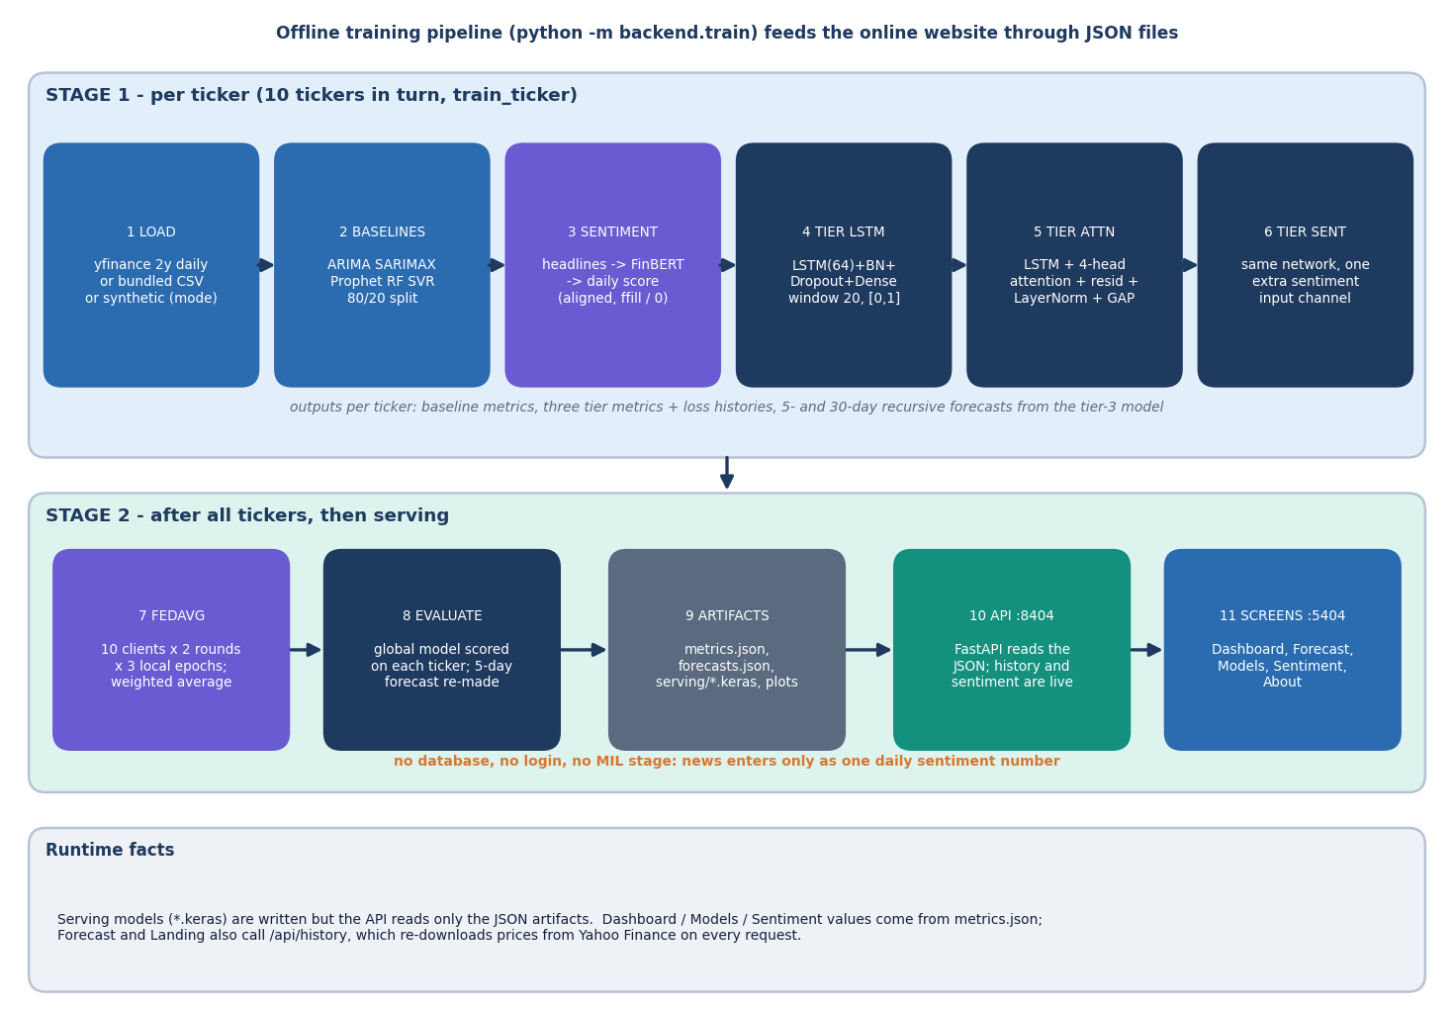
Figure 1: Offline training pipeline (python -m backend.train) in two stages, then serving of the JSON artefacts to the website.

1.2 Dataset
Prices. The ten tickers are TSLA, AAPL, AMZN, MSFT, GOOGL, NVDA, META, FDX, IBM and ORCL, the base paper's universe with Airbnb replaced by Meta [1]. The loader asks yfinance for two years of daily bars [33]; the shipped artefacts were trained on 501 rows per ticker, 2024-09-09 to 2026-09-08, all with mode live. If the download fails the loader reuses data/<T>.csv, and if that is missing it generates a geometric-Brownian-motion series with regime shifts and volatility clustering, saved with a # synthetic: true header. Every record carries its mode so that a synthetic series can never be mistaken for a real one. The application overwrites the CSV on each live pull, so the documentation experiments use a pinned snapshot, experiments/data_snapshot/, whose rows up to 2026-09-08 reproduce the stored last closes.
News in the product. No NEWSAPI_KEY was set, so all ten tickers used the built-in fallback: 166 to 191 headlines per ticker (about 1 to 3 per day for the last 90 trading days) generated from eleven fixed templates, 45 % positive, 25 % neutral and 30 % negative in expectation, and then scored by FinBERT-tone [16]. These headlines carry no information about the real market. The free NewsAPI tier returns only about a month of history [34], which is why the base paper's sentiment experiments are limited to 30 days.
Real news for the offline study. The multiple-instance study uses the news portion of FNSPID [11], read from a public mirror: 46,532 headline rows for seven tickers (AAPL, AMZN, FDX, MSFT, NVDA, ORCL, TSLA), of which 40,663 fall in 2022 and 2023; GOOGL and META have no headlines in this portion and IBM has seven. All rows carry day-level time stamps. Each article is tagged with every company it mentions, so a bag holds headlines only loosely about the ticker, the situation multiple-instance learning is meant for. Prices for this study are Yahoo Finance 2016 to 2023.
Table 2: Datasets used and their roles.
Data | Source | Size | Role
Daily prices (product) | Yahoo Finance via yfinance | 10 tickers x 501 rows | Training and serving
Price snapshot | Same, pinned 2024-09-09 to 2026-10-23 | 10 x 534 rows | Re-runs, forward test
Synthetic headlines | Eleven templates (sentiment.py) | 166 to 191 per ticker | Sentiment channel of the product
Real headlines | FNSPID news [11] | 46,532 rows, 7 tickers | Offline multiple-instance study
Prices for the study | Yahoo Finance 2016 to 2023 | 7 tickers, about 2,000 days each | Labels and price features

1.3 Preprocessing
Preprocessing is deliberately small and is the same for every deep tier. The feature matrix has the columns Open, High, Low, Close and Volume, plus the daily sentiment score for the third tier. Each column is scaled separately with MinMaxScaler, fitted on the first 80 % of the rows (400 of 501) and applied to all rows, with the result clipped to [0, 1]. Sliding windows of 20 trading days are cut from the scaled matrix; the target of a window is the Close of the day after it. The 481 windows are split chronologically 80/20 into 384 training and 97 test windows, and the training windows are further divided by Keras with a 15 % validation split taken from their end (326 / 58). The test period is therefore the last 97 trading days of the two-year series.
Three properties of this preprocessing matter for the results. First, the scaler never sees the test period, which avoids leakage, but the clip means that any test price above the training maximum becomes exactly 1.0; in the pinned data this affects 56 to 82 % of the test closes of AAPL, AMZN, GOOGL, NVDA and FDX. Second, the target is the next close itself rather than its change, so a model that merely repeats the last input already scores well on level errors. Third, sentiment alignment averages the headline scores per calendar date, places them on the trading dates, forward-fills the gaps and sets days before the first headline to zero; because the generator writes headlines only for the last 90 trading days, the channel is exactly zero for every training window and non-zero only in the test part.
Baselines are preprocessed differently, as in the base paper: ARIMA, SARIMAX and Prophet fit the close series on the first 80 % and forecast the whole remaining span without refitting; Random Forest and SVR use the previous 20 closes and predict one step ahead from actual lagged values. Headline scores are signed probabilities: +p, -p or 0 for positive, negative or neutral.

1.4 Algorithm Choice and Justification
Each model in the pipeline answers a specific question, and the table records why it was chosen and what the measurements of Chapter 8 showed about it.
Table 3: Algorithms, the reason for each and what was observed.
Algorithm | Role | Reason for choosing it | What the measurements show
ARIMA(5,1,0), SARIMAX [27] | Statistical baseline | Standard linear time-series models, in the base paper | Mean MAE $30.68 and $32.93; multi-step forecast without refit
Prophet [24] | Decomposable baseline | Trend and seasonality model in the base paper | Worst model: mean MAE $62.33
Random Forest, SVR [25], [26] | Machine-learning baselines | Non-linear regressors on lagged closes | Random Forest lowest MAE on 6 of 10 tickers (mean $13.18)
LSTM [12] | Sequence model | Captures temporal dependence in the price window | Mean MAE $44.11 (shipped scoring)
Multi-head attention [13] | Weights the time steps of the window | Base paper adds it to the LSTM to model long-range dependence | Best deep tier, mean MAE $22.36
FinBERT-tone [16], [17] | Headline sentiment | Pretrained on financial text, inference only, no labels needed | Works as a scorer; the channel it feeds is synthetic and empty during training
FedAvg [14] | Simulated decentralised training | Base paper's privacy argument; one client per ticker | Worse than local tiers (mean MAE $44.72)
Gated-attention MIL [10], [9] | Bag-level news model (offline study) | Only the day's outcome labels a bag of headlines, as the title requires | No gain over price-only on 1,309 test samples

The LSTM with attention was kept because it is the base paper's architecture and the tier comparison is the paper's ablation, not because it is expected to beat a persistence forecast. FinBERT-tone in inference mode was chosen because no labelled headlines exist for the ten tickers; the cost is a download of several hundred megabytes on first use.

1.5 Mathematical Formulation

1.5.1 Windows and scaling
Let x_t be the vector of the five price columns (and the sentiment score) on trading day t. Each column j is scaled with the minimum and maximum of its first 80 % of rows, and the input window and target are
x̃_t,j = clip((x_t,j − min_j) / (max_j − min_j), 0, 1), X_t = [x̃_(t−20), …, x̃_(t−1)], y_t = x̃_t,Close (1)

1.5.2 LSTM cell
The recurrent layer is the standard LSTM [12] with 64 units. With σ the logistic function and ⊙ the element-wise product, at each step
f_t = σ(W_f[h_(t−1), x_t] + b_f), i_t = σ(W_i[h_(t−1), x_t] + b_i), o_t = σ(W_o[h_(t−1), x_t] + b_o) (2)
C̃_t = tanh(W_C[h_(t−1), x_t] + b_C), C_t = f_t ⊙ C_(t−1) + i_t ⊙ C̃_t, h_t = o_t ⊙ tanh(C_t) (3)

1.5.3 Multi-head attention
The attention tier keeps the whole LSTM sequence H = [h_1, …, h_20] and applies four-head self-attention [13] with key size 16, adds the result back (residual connection), normalises and averages over time:
Attention(Q, K, V) = softmax(Q Kᵀ / √d_k) V, Z = LayerNorm(H + MultiHead(H, H, H)), z̄ = (1/20) Σ_t Z_t (4)
The vector z̄ passes through a 32-unit ReLU layer, dropout 0.2 and one linear output.

1.5.4 Daily sentiment
For ticker k and date d, let S_(k,d) be the set of headlines. FinBERT-tone returns a label and a probability p for each headline, and the headline score is s = +p for positive, −p for negative and 0 for neutral. The daily value is the mean, forward-filled and clipped:
σ_(k,d) = clip( mean_(h ∈ S_(k,d)) s_h , −1, 1 ), σ_(k,d) = σ_(k,d−1) if S_(k,d) = ∅, σ = 0 before the first headline (5)

1.5.5 Federated averaging
Each ticker i is a client with n_i training windows. In every round each client copies the global weights, trains for three local epochs and returns its weights; the server forms the weighted mean [14]:
w^(r+1) = Σ_(i=1..10) (n_i / n) w_i^(r), n = Σ_i n_i (6)
Because every ticker has 384 training windows the weights are equal and the average is a plain mean. The global model is then scored on each ticker's test windows using that ticker's own scalers.

1.5.6 Evaluation metrics and forecast band
For test targets y_i with predictions ŷ_i (inverse-scaled to dollars) and n test windows:
MAE = (1/n) Σ |y_i − ŷ_i|, MSE = (1/n) Σ (y_i − ŷ_i)², RMSE = √MSE, R² = 1 − Σ (y_i − ŷ_i)² / Σ (y_i − ȳ)² (7)
DA = (1/(n−1)) Σ_i 1[ sign(y_i − y_(i−1)) = sign(ŷ_i − y_(i−1)) ] (8)
The directional accuracy compares the sign of the actual move with the sign of the predicted level against the previous actual. For the multi-step forecast the recursion feeds each prediction back as the next input and the band widens with the square root of the horizon h, using σ_res, the standard deviation of the test residuals:
ŷ_(T+h) = f(window with ŷ_(T+h−1) appended), band_h = ŷ_(T+h) ± 1.96 σ_res √h, trend = up if ŷ_(T+5) ≥ y_T (9)
Two further quantities are used in Chapter 8 and are not computed by the application. The persistence baseline forecasts ŷ_t = y_(t−1). The true-target scoring computes the same metrics against the real closes instead of the clipped scaled targets.

1.5.7 Multiple-instance formulation (offline study)
In multiple-instance learning [9] the label belongs to a bag, not to its members. Here the bag B_(k,d) = {x_1, …, x_n} is the set of headlines of ticker k published before the close of day d, each instance x_i is represented by FinBERT-tone probabilities and a 64-component projection of its [CLS] vector, and the bag label is y = 1 if the close of day d+1 is above the close of day d. With an instance encoder h_i = ReLU(W_e x_i) the gated attention pooling of Ilse et al. [10] is
a_i = softmax_i( wᵀ ( tanh(V h_i) ⊙ sigmoid(U h_i) ) ), z = Σ_i a_i h_i, p(y = up) = sigmoid( f([LSTM(price window), z]) ) (10)
Mean pooling (a_i = 1/n) and max pooling are the simpler alternatives; an empty bag is replaced by a learned vector. The attention weights say which headlines the model relied on, which is the explainability the problem statement asks for.

1.6 Model Architecture and Training
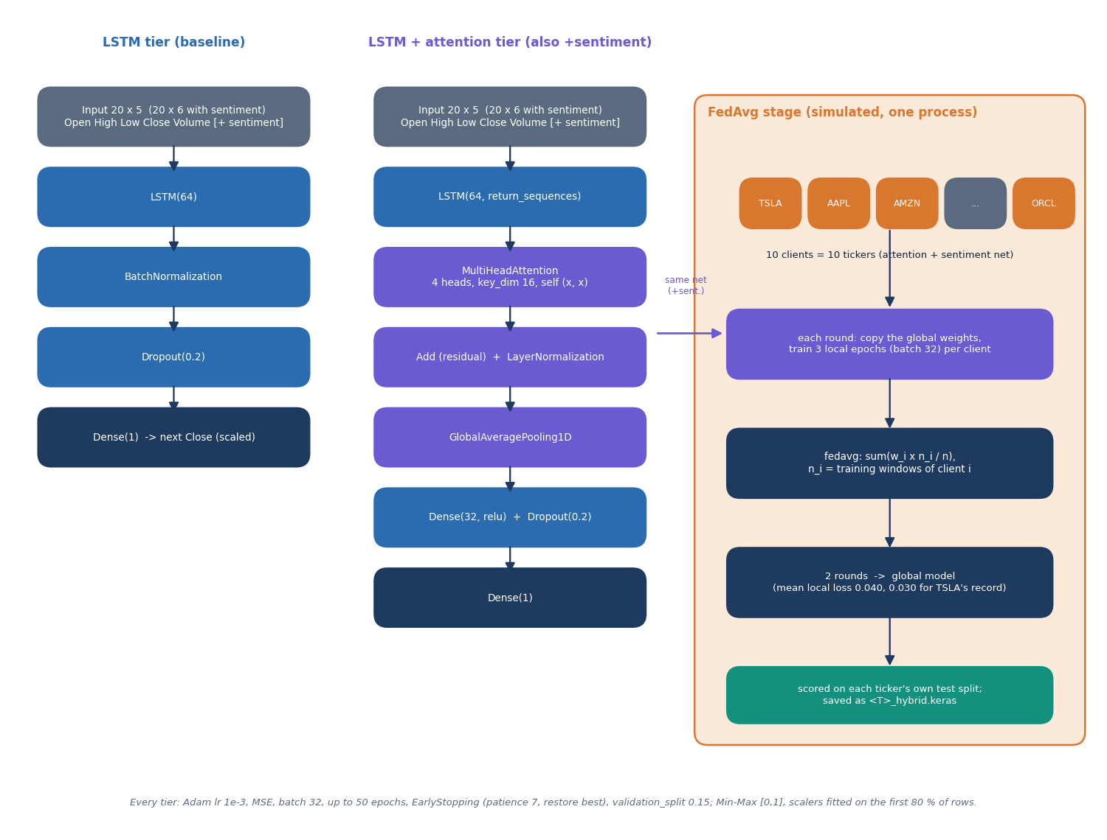
Figure 2: Architecture of the two network families (LSTM, and LSTM with four-head attention) and of the simulated FedAvg stage.
Table 4: Hyper-parameters (config.py, models_dl.py, federated.py, forecast.py).
Setting | Value
Window / split / batch / maximum epochs | 20 trading days / 80 % chronological / 32 / 50
LSTM tier | LSTM(64), BatchNorm, Dropout 0.2, Dense(1): 18,241 parameters (18,113 trainable)
Attention tier | LSTM(64, sequences), MultiHeadAttention(4 heads, key size 16), residual, LayerNorm, global average pooling, Dense(32, ReLU), Dropout 0.2, Dense(1): 36,801 parameters (37,057 with the sentiment column)
Optimiser and loss | Adam, learning rate 1e-3 [28]; mean squared error
Early stopping | Monitor validation loss, patience 7, restore best weights; validation split 15 %
Federated stage | 10 clients, 2 rounds, 3 local epochs per round, weighted average of weights
Seeds | TensorFlow and NumPy seed 42 in the product; seeds 42 to 46 in the documentation re-run
Forecast horizons / band | 5 and 30 trading days / 1.96 σ_res √h
Classical baselines | ARIMA(5,1,0); SARIMAX(1,1,1)(1,1,1,5); Prophet with daily and weekly seasonality; Random Forest 200 trees on 20 lags; SVR RBF C = 10, ε = 0.5

Training is cheap. In the five-seed re-run the three local tiers stopped after about 20 (LSTM), 17 (attention) and 17 (attention and sentiment) epochs on average, and one ticker and one seed (four local networks plus that ticker's share of the federated stage) took about 41 seconds on the six-core CPU used here, which was shared with other jobs. The shipped run saved one loss curve per local tier, and the federated stage logs the mean local loss of each round (0.0400 in round 1 and 0.0305 in round 2).

1.7 Multiple-Instance Learning Study (Offline)
The batch objectives ask for news treated as bags, directional prediction scored with accuracy, precision, recall and F1, and a comparison with a price-only baseline. The application does none of these, so the study was run as a separate script, scripts/mil_study.py, using real headlines. Its design is summarised below; its results are in Chapter 8.
Table 5: Design of the study.
Item | Choice
Bag and instance | All headlines of one ticker published before a day's close; instance = 3 FinBERT-tone probabilities + 64 PCA components of the [CLS] vector (PCA fitted on training headlines only)
Label | 1 if the next trading day's close is above today's close; bag-level only
Tickers and period | AAPL, AMZN, FDX, MSFT, NVDA, ORCL, TSLA; news era 2022 to 2023
Folds | Three expanding windows tested on Q2, Q3 and Q4 2023; validation = the two months before each test quarter; test predictions pooled (1,309 samples)
Price branch | LSTM(32) over 20 days of return, high-low range and log volume ratio (z-scored)
Bag models | Flat mean sentiment; MIL mean, max and gated-attention pooling (hidden size 32, attention size 16, at most 24 instances per bag); news-only attention; placebo with bags of other days
Training | AdamW, learning rate 2e-3, weight decay 1e-3 [29]; batch 128; at most 60 epochs; early stopping patience 7; five seeds
Metrics | Accuracy, precision, recall, F1 (up = positive), ROC-AUC; paired bootstrap against the price-only LSTM
Leakage controls | A headline is placed in the bag of the first trading day whose close is not earlier than its time stamp; scaling and PCA fitted on training data; the placebo gives each day the bag of another day of the same ticker

1.8 Evaluation Protocol
Five measurements are used in Chapter 8: the shipped metrics of artifacts/metrics.json; a five-seed re-run of the shipped pipeline on the same 501 rows; true-target scoring and the persistence baseline, which expose what the shipped scoring hides; the forward test of the stored forecasts (from the 2026-09-08 close) against the closes of the following 30 trading days, the only genuinely out-of-sample check; and the multiple-instance study of Section 6.7. Timings come from scripts/measure_api.py on 127.0.0.1.

2. NOVELTY AGAINST THE BASE PAPER

2.1 What the base paper contributes
The base paper [1] combines four ideas for short-term forecasting of ten technology and logistics stocks: an LSTM over a 20-day OHLCV window, multi-head attention on top of the LSTM, a sentiment channel built from FinBERT-tone scores of NewsAPI headlines, and a simulated federated-averaging stage in which each company is a client. It reports an average R2 of 0.91 over the ten companies, TSLA MSE 0.039, MAE 0.179 and R2 0.888, and a baseline-LSTM trend accuracy of 65.36 % over 100 runs per company. Its hybrid experiments use a one-month window because the NewsAPI free tier returns about 30 days of headlines, and federated learning is only simulated; the paper says both limits itself.

2.2 What QuantPulse shares with it
• The same four components in the same order: LSTM, LSTM plus 4-head attention, plus a sentiment channel, plus FedAvg, each tier added to the previous one (an ablation).
• The same five classical baselines (ARIMA, SARIMAX, Prophet, Random Forest, SVR), the same 20-day window, the same 5-day and 30-day horizons, and a one-LSTM-layer-with-64-units design with batch normalisation and dropout.
• FinBERT-tone [16] scoring of headlines, and the ten-company universe (Airbnb is replaced by Meta because Airbnb's history is short).

2.3 What is different in this project
• Data scale. Two years of daily prices (501 training rows per ticker, 97 test windows) instead of a one-month window, so the test period contains regime changes that a 30-day window cannot show.
• Scoring against real closes. The product's own test scoring clips targets to the training range. The re-run scores the same predictions against the real closes ('true-target' scoring) and adds a persistence baseline (yesterday's close). On that scale the best deep tier has a mean absolute error of $29.37, against $6.24 for persistence.
• A forward test. The stored forecasts, made from the 2026-09-08 close, were compared with the 30 trading days that actually followed: the 5-day forecasts averaged -14.8 % against an actual -0.4 %, and the trend flag was right for 4 of 10 tickers.
• A placebo and five seeds. A sentiment channel shuffled in time and five training seeds show that the sentiment tier's behaviour is an artefact of its zero-filled channel, not a finding about news.
• An offline multiple-instance-learning study on real headlines. The batch title asks for MIL, which the base paper does not use. A separate script bags 46,532 real FNSPID headlines per ticker and trading day, trains mean, max and gated-attention MIL pooling next to a price-only LSTM, and reports accuracy, precision, recall and F1 on 1,309 test samples [10], [11].
• A reproducible experiment suite and tests. scripts/run_experiments.py, scripts/mil_study.py, 56 pytest tests and a 26-check smoke test regenerate every number in the documents.

2.4 What is not new
The model architectures, the FedAvg rule [14], the baselines and the FinBERT scorer are the base paper's or are published components used unchanged. The application shell (FastAPI, React, a forecast screen with confidence bands) is engineering rather than research. The MIL formulation follows Dietterich et al. [9] and the attention pooling follows Ilse et al. [10]; applying MIL to daily news bags for stock direction was proposed earlier by Zhang et al. [6] and Deng and Yiu [8], so this project's contribution there is a small, honest replication on a new dataset, not a new method.
In the study's own diagnostics the gated-attention weights stay close to uniform (on average the top weight is 1.15 times 1/n over 8 inspected test days), so the model did not learn to prefer particular headlines; the study therefore reports a negative result, not a new method.
The comparison with the base paper is indicative only. The paper's window, scaling units and split differ from ours, so its R2 of 0.91 and its 65.36 % trend accuracy are not reproduced and not contradicted by a like-for-like run.

3. KEY CONTRIBUTIONS
The contributions of the project, stated at the strength the evidence supports, are:
1. A working forecasting product, QuantPulse: a FastAPI service with seven JSON endpoints, a six-screen React website, ten tickers, five classical baselines, four deep-model tiers and 5- and 30-day forecasts with confidence bands, started by one run.bat.
2. An implementation of the base paper's ablation (LSTM, attention, sentiment, simulated FedAvg) that can be re-run end to end with python -m backend.train, with its results shown on a model-comparison screen.
3. An evaluation that goes beyond the base paper: five seeds, a persistence baseline, true-target scoring and a forward test. It shows that no deep tier beats 'tomorrow equals today' (mean MAE $6.24 for persistence against $29.37 for the best tier) and that the stored 5-day forecasts were wrong in direction for 6 of 10 tickers.
4. Four defects documented with evidence: clipped test targets that inflate directional accuracy (shipped 68.3 % against 53.0 % on real closes), a sentiment channel that is zero throughout training, FedAvg across differently scaled clients, and artefacts older than the data.
5. An offline multiple-instance-learning study on real headlines (seven tickers, 2022-2023, 1,309 test samples, five seeds). The best MIL variant gained +2.1 accuracy points over the matched price-only LSTM with a 95 % interval of [-0.9, +5.2], and no model beat the always-up rate of 53.6 %: no evidence that news bags improve next-day direction at this sample size.
6. A tested, documented artefact: 56 unit and API tests, a 26-check smoke test, 12 design diagrams, 17 real screenshots and scripts that regenerate every figure from JSON.

